Symbols of ER diagram that still in use another one modern approach of symbols discussed below,

studentcan any one of it:--

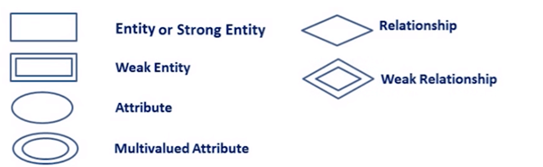

E-R diagram example :--

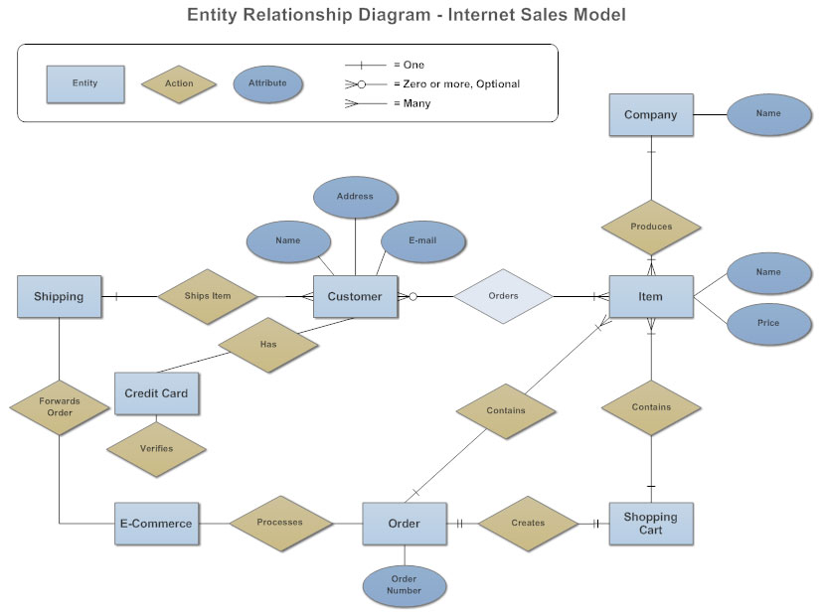

here the lines with certain symbol depicts the releationship:--

one to one

one to many

many to many

some links to study :--

<https://www.studytonight.com/dbms/generalization-and-specialization.php>

<https://www.smartdraw.com/entity-relationship-diagram/>

Case study:--

In a university, a Student enrolls in Courses. A student must be assigned to at least one or more Courses. Each course is taught by a single Professor. To maintain instruction quality, a Professor can deliver only one course?

### Step 1) Entity Identification

We have three entities

* Student
* Course
* Professor

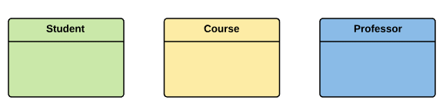

### Step 2) Relationship Identification

We have the following two relationships

* The student is assigned a course
* Professor delivers a course

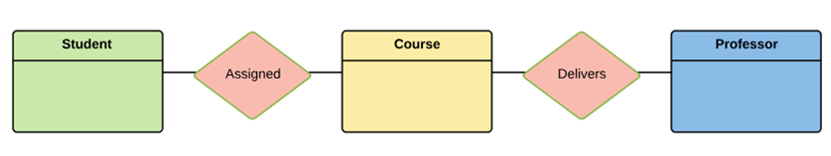

### Step 3) Cardinality Identification

For them problem statement we know that,

* A student can be assigned multiple courses
* A Professor can deliver only one course

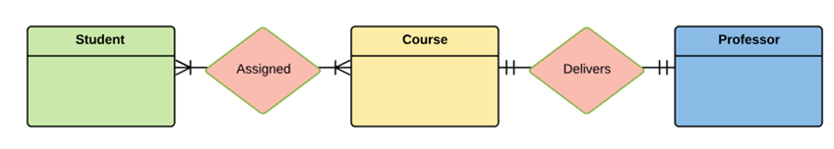

### Step 4) Identify Attributes

You need to study the files, forms, reports, data currently maintained by the organization to identify attributes. You can also conduct interviews with various stakeholders to identify entities. Initially, it's important to identify the attributes without mapping them to a particular entity.

Once, you have a list of Attributes, you need to map them to the identified entities. Ensure an attribute is to be paired with exactly one entity. If you think an attribute should belong to more than one entity, use a modifier to make it unique.

Once the mapping is done, identify the primary Keys. If a unique key is not readily available, create one.

|  |  |  |
| --- | --- | --- |
| Entity | Primary Key | Attribute |
| Student | Student_ID | StudentName |
| Professor | Employee_ID | ProfessorName |
| Course | Course_ID | CourseName |

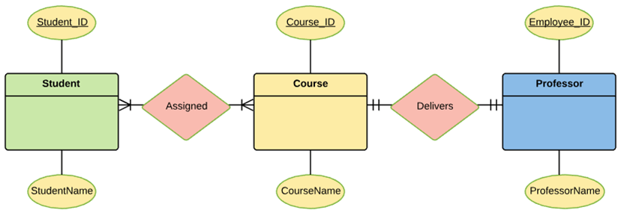For Course Entity, attributes could be Duration, Credits, Assignments, etc. For the sake of ease we have considered just one attribute.

### Step 5) Create the ERD

A more modern representation of ERD Diagram

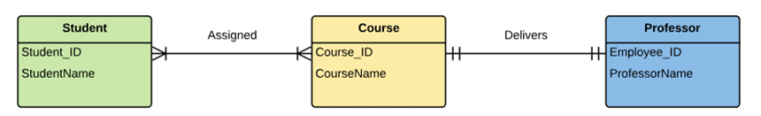

the symbols used here is modern approach , one can use this modern approach else can use